
New Real-Time Voltage Stability Indicators Based on

21, rue d’Artois, F-75008 PARIS C4-109 CIGRE 2008
http : //www.cigre.org
Phasor Measurement Unit Data

Sandro Corsi Glauco N. Taranto Leonardo N. A. Guerra
CESI S.p.A. COPPE/UFRJ COPPE/UFRJ
Italy Brazil Brazil

SUMMARY
This paper analyses and compares the performances of a number of proposed voltage instability risk indicators based on a new real time identification algorithm elaborating, at a given grid bus, the local phasor measurements at fast sampling rate. The effectiveness and the differences of the analyzed indicators, also considering the computing time they require, are checked at EHV load and transit buses. Risk reduction by combining more than one of the proposed indicators is analyzed and tested also. All the risk criteria are based on the real-time computation of the Thevenin equivalent impedance of the classic electrical circuit given by an equivalent generator connected to an equivalent load impedance through an equivalent connecting impedance. The main power of the proposed indicators lies in the innovating algorithm utilized for the real-time adaptive identification of the Thevenin’s voltage and impedance equivalents. The algorithm effectiveness and robustness is guaranteed by a detailed sensitivity analysis of previous studies. The paper presents important numerical results on the proposed real time voltage instability risk indicators from the actual Italian EHV network.
KEYWORDS
Voltage Stability, PMU, Dynamics, Long-term Voltage Stability, Thevenin Equivalent, Online VSA.

I. Introduction
Voltage instability in the transmission networks has led or significantly contributed to some major blackouts around the world. Its timely recognition is very crucial to allow effective control and protection interventions. On this concern, a worldwide interest in defining effective real-time voltage stability indicators, under the assumption of very fast measurements of system electrical variables (use of Phasor Measurement Unit – PMU [1,2]), is growing. By measuring the local voltage and current phasors at an EHV bus, the voltage instability analysis can be performed by considering the classic Thevenin equivalent “seen” from the bus [3,4,5]. As generally understood, the voltage instability is linked to the condition of equality between the absolute value of two equivalent impedances – the load impedance and the Thevenin impedance – this equality corresponding to the maximal power transfer.
One of the first works on the subject [3] refers to the two-bus Thevenin equivalent system, as depicted in Fig.1. The identification of $E_{\text{Th}}$and$Z_{\text{Th}}$ is based on a recursive least-square identification method applied to the local voltage and current phasor measurements. Results are presented for P-constant loads as a sequence of power flow solutions, resembling a continuation power flow.
The works [5,6] differ in the identification method utilized, which is simplified to achieve a high-speed voltage instability risk evaluation. The work [5] uses the concept of insensitivity of the apparent power at the receiving end of the transmission line to infer the voltage instability proximity, whereas the work [6] uses the same concept of Thevenin equivalent and relies on the Tellegen’s theorem to identify the Thevenin parameters.
In the paper [4], the authors extend the previous analyses to ZIP loads and present a mechanism to include the Z-constant and I-constant portions of the load into the equivalent Thevenin impedance, allowing to conclude that maximum loadability and voltage instability occur at the same point. They also propose to monitor the status of the OELs of nearby generators and use the information for voltage instability proximity indication.
The performed analyses give evidence of the critical aspects, from the practical point of view, of methodologies based on real-time measurements at a given bus [3-6]. The main critical aspects are:
- Computing uncertainty of the equivalent grid parameters depending on the identification method, and their high sensitivity to small changes of local measurements at fast sampling rate;
- Computing time which often does not allow enough speed for real-time applications;
- The significant performance differences of the real system with respect to the simple electrical model of the considered equivalent circuit, when approaching the voltage instability condition;
- The unknown parameters of the ZIP load required in [4] when applied in the field;
- The absence of EHV transit buses from these analyses.
This paper has the objective to overcome the above-mentioned criticisms by defining a variety of effective real-time indicators, based on the real-time identification algorithm introduced in [1], well developed and tested [10] and able to effectively support practical applications.
For voltage stability studies, some basic and fundamental considerations should be put in evidence [7-9]. The first point is that the Thevenin equivalent has to represent a detailed dynamic model; therefore, its two parameters changes continuously and speedily while approaching the maximum loadability. The second refers to the local area OELs and OLTCs whose dynamics strongly impact on the bus maximum loadability and voltage instability. The third refers to the P-constant load analysis, which is not adequate for a correct identification in real systems, where a mixed ZIP load is usually adopted. The fourth point distinguishes the maximum loadability point (PV curve nose) from the real instability point, which in general occurs at very low voltage. The last basic consideration refers to the high speed the PV curve equilibrium point moves from the PV curve nose tip to the first unstable point at lower voltage. This fact confirms the practical importance of the nose tip identification to prevent against voltage instability, as well as the need of a very fast identification procedure when approaching the voltage instability limit. According to these fundamental considerations the proposed new way is capable to identify in real-time the Thevenin equivalent, with higher precision in proximity of the voltage instability where the OELs and OLTCs operate. This faster-change dynamic period also corresponds to the relevant simultaneous and in opposite direction variations of the load and the Thevenin equivalent impedances. The adopted algorithm distinguishes these critical variations from those happening during the normal operating conditions, and therefore to allow the needed timely alarm at the beginning of the voltage degradation process. This algorithm was tested through time-domain simulations performed in a large and realistic representation of the EHV Italian network. Excellent results achieved on both load and transit buses.
The paper preliminarily summarizes the main aspects of the new algorithm for fast-tracking the Thevenin parameters (voltage and reactance) based on the local voltage and current phasor measurements. Contrary to the least-square-type identification methods, that generally need a large data window to suppress oscillations, the proposed algorithm has a good feature to have these oscillations filtered without significantly delaying the identification process. The effectiveness of the algorithm was confirmed by the dynamic tests performed with very clean and precise results, notwithstanding the continuous changing of the real system data (50 Hz band) and the identification high speed (average based on four sampling data of the last 80ms) imposed.
This paper moves to the subsequent step by defining and testing a variety of real-time reliable indicators to be used in practice, very simple, at low computation cost and mainly based on the real time identification results, by considering distances between $X_{\text{Th}}^{i}$and $\left|{\bar{Z}}_{L}^{i}\right|$, or $E_{\text{Th}}^{i}$and $E_{\text{Th}}^{\text{max}}$ (superior extreme), as well as by the slope of the variables under identification to predict the voltage instability approaching.
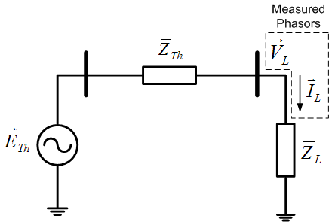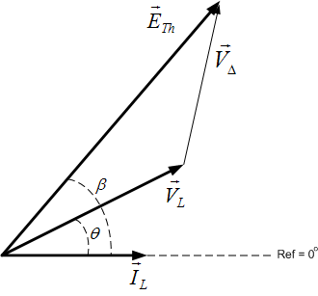

Fig. 1. Two-bus Thevenin Equivalent Circuit Fig. 2. Phasor Diagram of the Two-Bus Equivalent Circuit

II. The Identification Algorithm
The works reported in [3, 4, 6] proposes the two-bus Thevenin equivalent circuit, as illustrated in Fig.1, to analyze and quantify the voltage stability margin. The maximum power transfer to the load in the electric circuit shown in Fig.1 occurs when
$$\left|{\bar{Z}}_{L}\right|=\left|{\bar{Z}}_{\text{Th}}\right|$$ | (1)
Where
$${\bar{Z}}_{\text{Th}}=R_{\text{Th}}+{\text{jX}}_{\text{Th}}$$ | (2) ${\bar{Z}}_{L}=Z_{L}∠θ=R_{L}+{\text{jX}}_{L}$ (3)
This circuit represents the entire network “seen” from the considered bus in an equivalent way.
According to the phasor diagram show in Fig. 2 the following relationship holds:
$${\vec{E}}_{\text{Th}}=E_{\text{Th}}∠β$$ | (4) ${\vec{V}}_{L}=V_{L}∠θ$ (5) ${\vec{I}}_{L}=I_{L}∠0^{∘}$ (6)
$${\vec{V}}_{Δ}={\bar{Z}}_{\text{Th}}×{\vec{I}}_{L}=R_{\text{Th}}I_{L}+{\text{jX}}_{\text{Th}}I_{L}$$ | (7) ${\vec{E}}_{\text{Th}}={\vec{V}}_{L}+{\vec{V}}_{Δ}$ (8)
Separating (8) into real and imaginary parts, yields:
$$E_{\text{Th}}\text{cos}β=R_{\text{Th}}I_{L}+V_{L}\text{cos}θ$$ | (9) $E_{\text{Th}}\text{sin}β=X_{\text{Th}}I_{L}+V_{L}\text{sin}θ$ (10)
For the equivalent Thevenin impedance “seen” from an EHV bus, we have$X_{\text{Th}}\text{>>}R_{\text{Th}}$, and the assumption of$R_{\text{Th}}≈0$is very reasonable. Therefore, an initial estimation for$β$is given by (11):
$$β={\text{cos}}^{−1}\left(\frac{V_{L}\text{cos}θ}{E_{\text{Th}}}\right)$$ | (11) $E_{\text{Th}}^{0}=\frac{E_{\text{Th}}^{\text{max}}−E_{\text{Th}}^{\text{min}}}{2}$ (12)
Since$V_{L}$and$θ$are measured quantities taken from the PMUs, the initial estimation of$β$still depends on$E_{\text{Th}}$. The admissible range for$E_{\text{Th}}$must be in agreement with the electric circuit laws, i.e., up to the maximum power transfer point, its minimum value ($E_{\text{Th}}^{\text{min}}$) corresponds to the load voltage, and its maximum value ($E_{\text{Th}}^{\text{max}}$) corresponds to the voltage when$Z_{L}=X_{\text{Th}}$(with $R_{\text{Th}}=0$). In normal operating conditions the load impedance is much higher than the equivalent Thevenin impedance, a good start estimation value for$E_{\text{Th}}$is the arithmetic average of its extreme values given by (12).
Where$E_{\text{Th}}^{\text{min}}=V_{L}$and$E_{\text{Th}}^{\text{max}}=V_{L}\text{cos}θ\text{/cos}β$, with$β$obtain-ed from, $\text{tan}β=(Z_{L}I_{L}+V_{L}\text{sin}θ)/(V_{L}\text{cos}θ)\text{.}$
Inside the possible range for$E_{\text{Th}}$and$X_{\text{Th}}$, the following facts can be proved [10]: in case of over-estimated$E_{\text{Th}}$, also$X_{\text{Th}}$ is over-estimated, and increasing the load impedance (i.e., reducing the power consumption of the load) the value of the estimated$X_{\text{Th}}$ also increases. In the case of under-estimated$E_{\text{Th}}$, also$X_{\text{Th}}$is under-estimated, and increasing the load impedance, the value of the estimated$X_{\text{Th}}$decreases. Symmetrical characteristic happens when decreasing the load impedance. So, assuming that$E_{\text{Th}}$and$X_{\text{Th}}$are constant in the brief interval of their identification, the proposed adaptive algorithm will reduce$E_{\text{Th}}$when the variation of$X_{L}$and the variation of the estimated$X_{\text{Th}}$have the same direction, otherwise it will increase$E_{\text{Th}}$. Results presented in [1] showed that the simplification of considering$E_{\text{Th}}$as a fixed value during load build-up, resulted on an identification of$X_{\text{Th}}$critically dependent on the value fixed for$E_{\text{Th}}$.
Considering now, that we know in which direction we should update$E_{\text{Th}}$, we need to establish how large this variation should be. This quantity is calculated as following:
$$ε_{E}=\text{min}(ε_{\text{inf}},ε_{\text{sup}},ε_{\text{lim}})$$ | (13)
With
$$ε_{\text{inf}}=\left|E_{\text{Th}}^{i−1}−V_{L}^{i}\right|$$ | (14) $ε_{\text{sup}}=\left|E_{\text{Th}}^{i−1}−E_{\text{Th}}^{{\text{max}}^{i}}\right|$ (15) $ε_{\text{lim}}=\left|E_{\text{Th}}^{i−1}×k\right|$ (16)
With$k$being a pre-specified parameter chosen in such way to constrain the identification error within narrower bounds, and $i$ being the corresponding time step. Most of the times $ε_{\text{lim}}$ drives the identification process, so its specification has a major impact in the process. The quantities $ε_{\text{inf}}$and$ε_{\text{sup}}$are active only when the estimated$E_{\text{Th}}$is close to the edges of its feasible range.
The adaptive algorithm that tracks the correct value of$E_{\text{Th}}$to identify$X_{\text{Th}}$ is given in below:
Algorithm
Step1 – Estimate initial values for$E_{\text{Th}}^{0}$according to (12) and$β^{0}$according to (11) already considering$E_{\text{Th}}^{0}$
Step 2 – Calculate$X_{\text{Th}}^{0}$from (10)
Step 3 – Calculate$E_{\text{Th}}^{i}$according to the conditions:
If load impedance variation is negative do
If then $E_{\text{Th}}^{i}=E_{\text{Th}}^{i−1}−ε_{E}$
If then $E_{\text{Th}}^{i}=E_{\text{Th}}^{i−1}+ε_{E}$
If load impedance variation is positive do
If then $E_{\text{Th}}^{i}=E_{\text{Th}}^{i−1}+ε_{E}$
If then $E_{\text{Th}}^{i}=E_{\text{Th}}^{i−1}−ε_{E}$
If load impedance is constant: $E_{\text{Th}}^{i}=E_{\text{Th}}^{i−1}$
Step 4 – Calculate $β^{i}$ and $X_{\text{Th}}^{i}$
Step 5 – Increment $i$ and go to Step 3
OBS: $X_{\text{Th}}^{i∗}$is an intermediate evaluation of $X_{\text{Th}}^{i}$that takes into account the instantaneous values of the voltage and current phasors.
One possible variant of the algorithm is with respect to the calculation of$E_{\text{Th}}$. For the calculation of$β^{i}$and$X_{\text{Th}}^{i}$in Step 4 instead of using the value of$E_{\text{Th}}^{i}$at iteration$i$, a moving average of$E_{\text{Th}}$calculated over a window of appropriate size (n) can be used. This variant has the advantage to filter the identified variables paying the price of a slower identification process.
III. The Proposed Indices
The identification algorithm described in Section II allows the computation of a variety of real-time reliable indicators to be used in practice, very simple and at low computation cost, mainly based on the distance between $X_{\text{Th}}^{i}$and $\left|{\bar{Z}}_{L}^{i}\right|$, or $E_{\text{Th}}^{i}$and $E_{\text{Th}}^{\text{max}}$, as well as on the slope of the variables under identification. In [9] the authors proposed a simple index comprising the ratio between $X_{\text{Th}}^{i}$ and $\left|{\bar{Z}}_{L}^{i}\right|$, namely index I0. I0 indicates the correct instant of the maximum power transfer; therefore it will be a reference for the others indices proposed for practical applications. Analogously, the following indicator I6 is another reference for comparison because it is not based on the here proposed identification method but simply uses the voltage measurement at the considered EHV bus.
The proposed indicators, I1, …I5, to be useful in practice for power system control and protection, have to predict in real-time and with high reliability, the approaching of the PV curve tip at the considered bus. Therefore the correct indication of voltage instability high risk, in advance of some seconds, is their objective. The indicators parameters have been tuned on the base of data coming from a very detailed dynamic simulation of the Italian transmission system, in front of load increase and heavy unusual perturbations for testing their correct performance and robustness. Basically, all the proposed indices have to be tuned on the threshold and the filter. The threshold is value at the right-hand-side of the index function while the filter averages the (m) subsequent indicator values related to the (m) consecutive identification updates. The parameter m defines the size of the filter’s “moving window” as m times the sampling time. The results in Section IV refer to a sampling rate of 20ms and m = 4.
The proposed Indices I0, I1, I2 and I3 are related to the Thevenin reactance identification, whereas I4 and I5 are related to the Thevenin voltage identification.
Index I0: ${\left|{\bar{X}}_{{\text{Th}}_{i}}\right|}/{\left|{\bar{Z}}_{\text{Load}}\right|}≥1$
This instantaneous index (m = 1) is based, at each step of sampling, on the measurement and identification of $Z_{\text{Load}}$and $X_{\text{Th}}$respectively. I0 indicates, as reference, the instant of the maximum power transfer.
Index I1: ${\left|{\bar{X}}_{{\text{Th}}_{i}}\right|}/{\left|{\bar{Z}}_{\text{Load}}\right|}≥0\text{.}\text{98}$
Index I1 differs from I0 simply for the threshold, diminished from 1 do 0.98, and for an averaging filter (m=4 in the performed tests) to compute $X_{\text{Th}}$. Obviously, index I1 has the objective to trigger the voltage instability risk before I0.
Index I2: ${\bar{X}}_{{\text{Th}}_{i}}+ρ_{X}\frac{d{\bar{X}}_{{\text{Th}}_{i}}}{\text{dt}}Δt>\left|Z_{\text{Load}}\right|$
Index I2 makes use of the derivative term on $X_{\text{Th}}$ to anticipate the instability limit. The gain $ρ_{X}$ amplifies the derivative term contribution computed considering a time interval $Δt$ of “g” times the sampling interval. The filter on the index computing based on “m” steps. In the performed tests: $ρ_{X}=\text{10}$; g = 20; m=4.
Index I3: $\left|{\bar{Z}}_{\text{Load}}\right|−({\bar{X}}_{{\text{Th}}_{i}}+σ_{X_{i}})≤K_{σ}σ_{X\text{min}}$
Index I3 makes use of the $X_{\text{Th}}$standard deviation to reduce the difference with respect to $Z_{\text{Load}}$. The threshold is based on the minimum standard deviation to be achieved during the$X_{\text{Th}}$identification, amplified by the gain $K_{σ}$. The filter on the index computing based on “m” steps. In the performed tests: $σ_{X\text{min}}=0\text{.}\text{035}$; $K_{σ}$ = 30; m=4.
Index I4: $\left|{\bar{E}}_{i}\right|+ρ_{E}\frac{d\left|{\bar{E}}_{i}\right|}{\text{dt}}Δt>{\overline{E}}_{\text{max}}$
Index I4 refers to the identification of the Thevenin voltages $E_{\text{Th}}^{i}$ and $E_{\text{max}}^{i}$and makes use of the derivative term on $E_{\text{Th}}^{i}$ to anticipate the instability limit. The gain $ρ_{E}$ amplifies the derivative term contribution computed considering a time interval $Δt$ of “g” times the sampling interval. The filter on the index computing based on “m” steps. In the performed tests: $ρ_{E}=\text{10}$; g = 20; m=4.
Index I5: $\left|{\bar{E}}_{\text{max}}\right|−\left|{\bar{E}}_{i}\right|<ε_{E_{3}}=0\text{.}\text{01}\left|{\bar{E}}_{\text{max}}\right|$
Index I5 refers to the identification of the Thevenin voltages $E_{\text{Th}}^{i}$ and $E_{\text{max}}^{i}$and makes use of a threshold based on $E_{\text{max}}^{i}$. The filter on the index computing based on “m” steps. In the performed tests: m=4.
Index I6: $\left|{\overline{V}}_{i}\right|+ρ_{V}\frac{d\left|{\overline{V}}_{i}\right|}{\text{dt}}Δt≤0\text{.}\text{85}$
Index I6 refers to the identification of the Thevenin voltages V and makes use of its derivative to anticipate the instability limit. The gain $ρ_{V}$ amplifies the derivative term contribution computed considering a time interval $Δt$ of “g” times the sampling interval. The threshold cannot be higher than 0.85 in practice. The filter on the index computing based on “m” steps. In the performed tests: $ρ_{V}=\text{10}$; g = 20; m=4.
IV. Performance of the Indices in Front of Load Increase
This section shows the performance of the proposed indices to the EHV Italian electrical network. The data collected in computer simulation for the voltage and current phasors have a sampling rate of 20ms. The Italian system analyzed contains the 380kV and 220kV networks. The system configuration has 2549 buses, 2258 transmission lines, 134 groups of thermal generators and 191 groups of hydro generators. Dynamic models for the generator, AVR, OEL, governor and OLTC are considered. The system load is approximately 50 GW, represented as a static model with α=0.7 and β=2.0 in (17). The system is under primary voltage and frequency control only.
$$P_{L}=P_{o}×{\left(\frac{V_{L}}{V_{o}}\right)}^{α}$$ | $$Q_{L}=Q_{o}×{\left(\frac{V_{L}}{V_{o}}\right)}^{β}$$ | (17)
Two sets of tests were performed, one at the Brugherio 380kV bus in Milano Area and the other at the Poggio a Caiano 380kV bus in Firenze Area.
Application to the Brugherio and Poggio a Caiano Buses
The tests consisted of increasing the load, while maintaining the power factor constant, at the neighboring buses at a given rate and at the considered load bus at a higher rate. Our objective in testing the proposed indices was not to find which bus would first exhibit a voltage instability problem, instead, how the indices would behave as the voltage instability point was reached at the bus most prone to instability. The analysis performed in the Milano and Firenze Areas consisted of increasing the local area load by a rate of 10%/min maintaining constant the power factor. The load at the Brugherio and P. a Caiano buses was increased by a rate of 40%/min.
Table I summarizes the performance of the proposed indices in terms of the time (in seconds) where a voltage instability alarm would trigger.

Table I – Time in seconds to voltage instability given by each index
Bus | I0 | I1 | I2 | I3 | I4 | I5 | I6
Brugherio | 487,0 | 481,5 | 473,9 | 483,3 | 473,9 | 481,4 | 612,5
P. a Caiano | 1138,5 | 1130,5 | 1117,1 | 1122,4 | 1117,1 | 1130,5 | 966,2

Figs.3-8 show the simulated results obtained for each one of the indices defined in Section III for the Brugherio Bus, and Figs. 9-14 for the P. a Caiano Bus.

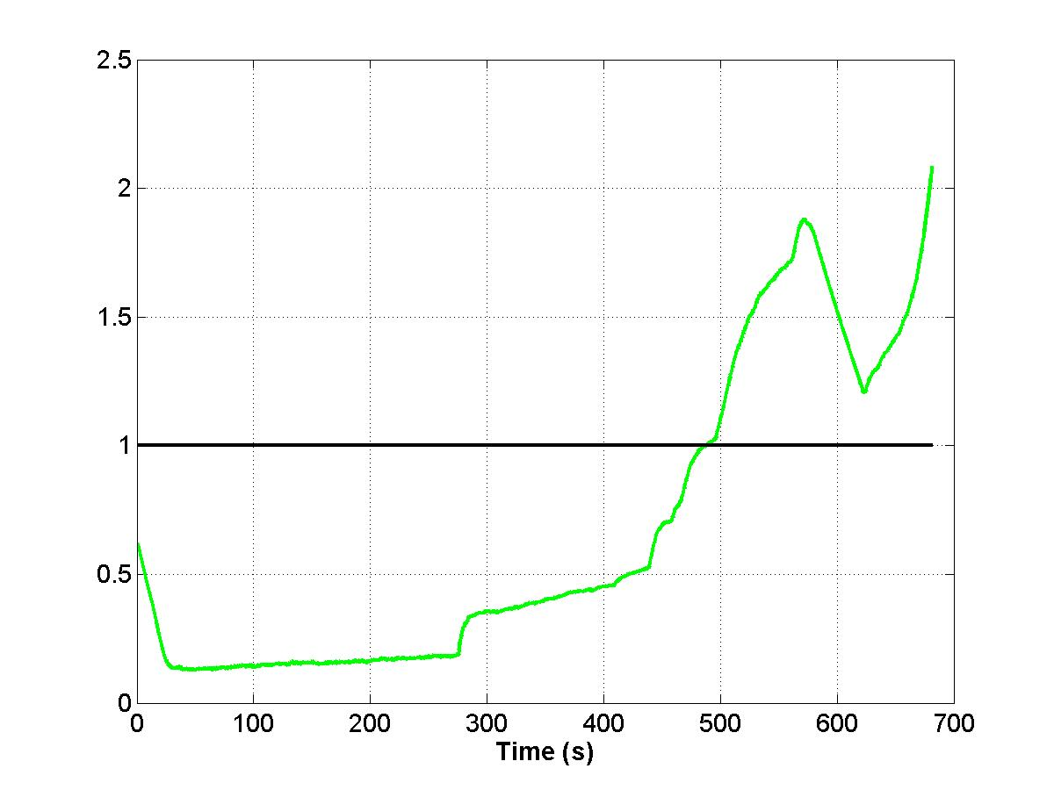 | 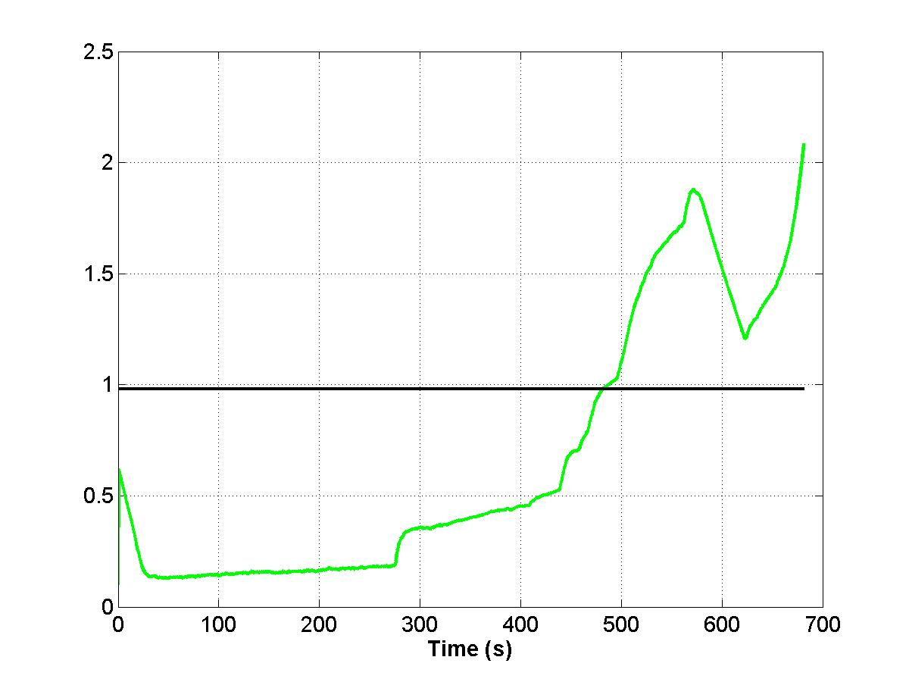 | 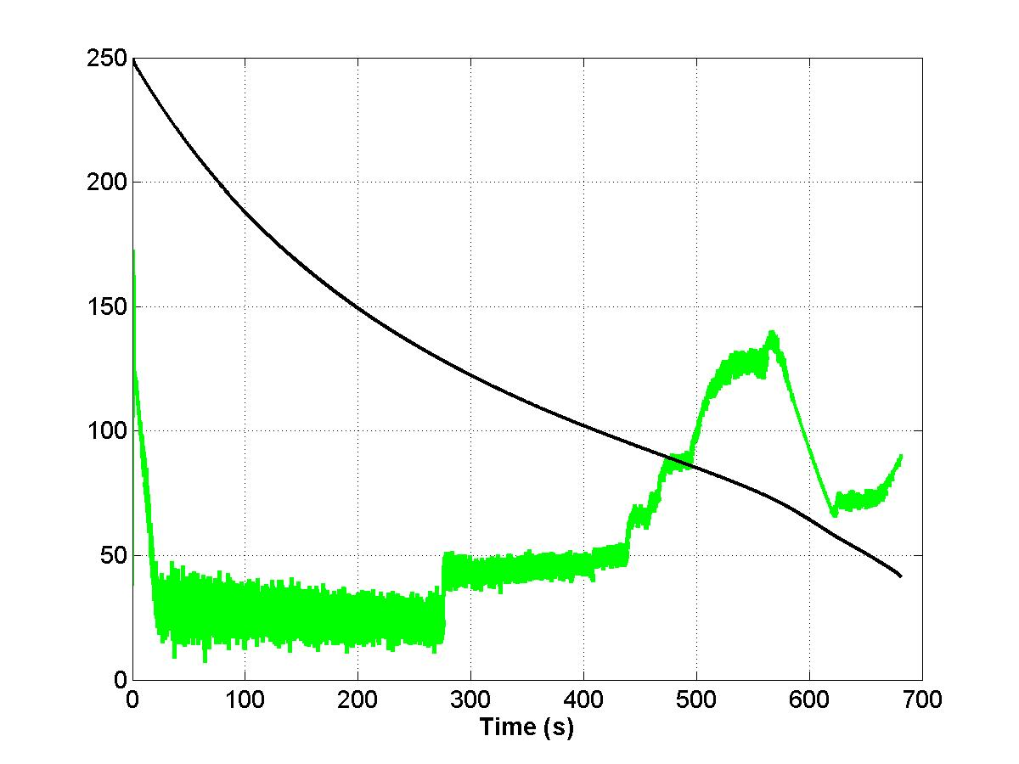
Fig. 3. Index I0 – Brugherio | Fig. 4. Index I1 – Brugherio | Fig. 5. Index I2 – Brugherio

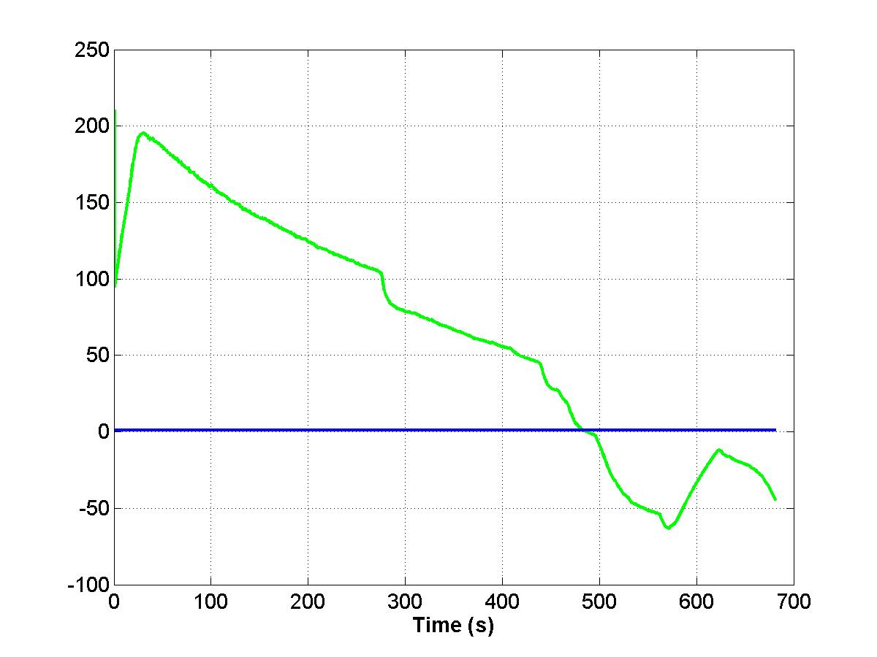 | 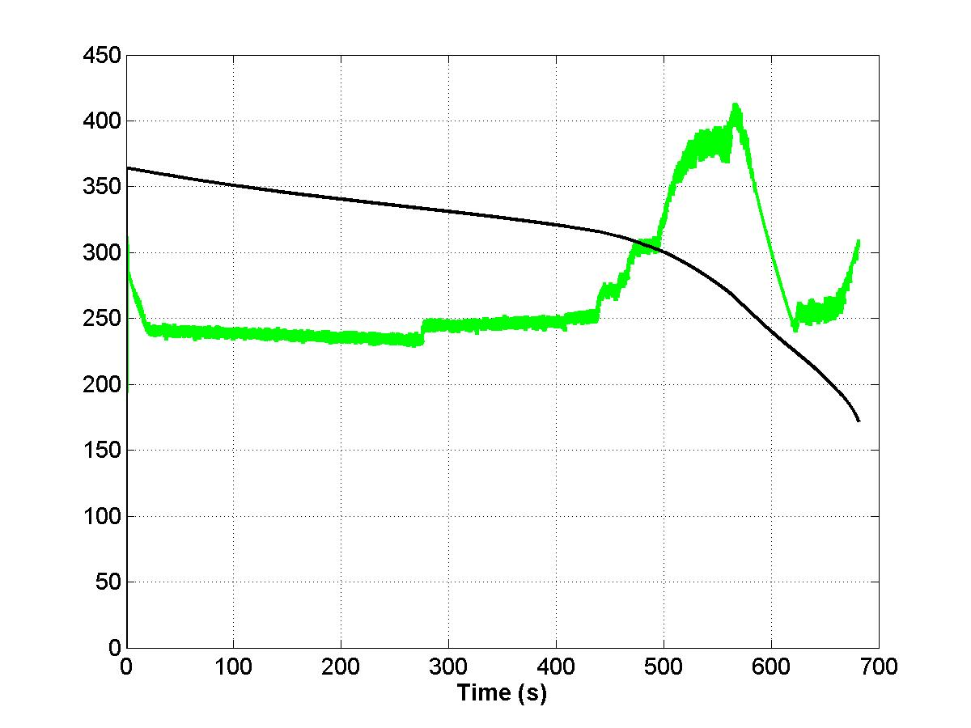 | 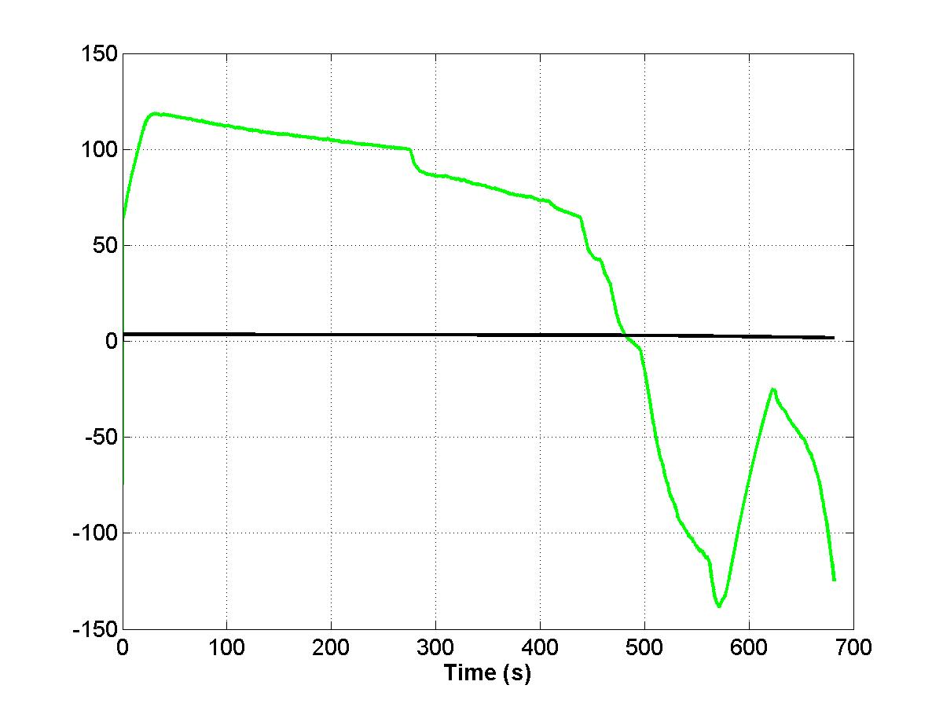
Fig. 6. Index I3 – Brugherio | Fig. 7. Index I4 – Brugherio | Fig. 8. Index I5 – Brugherio

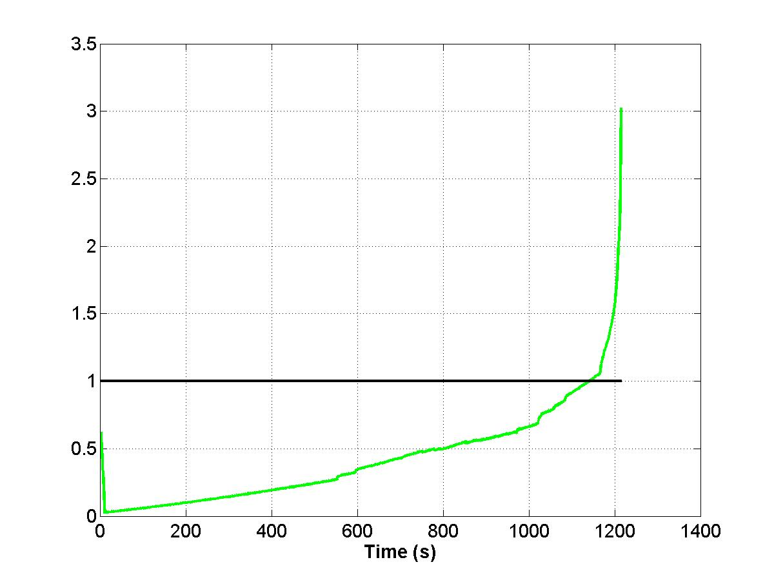 | 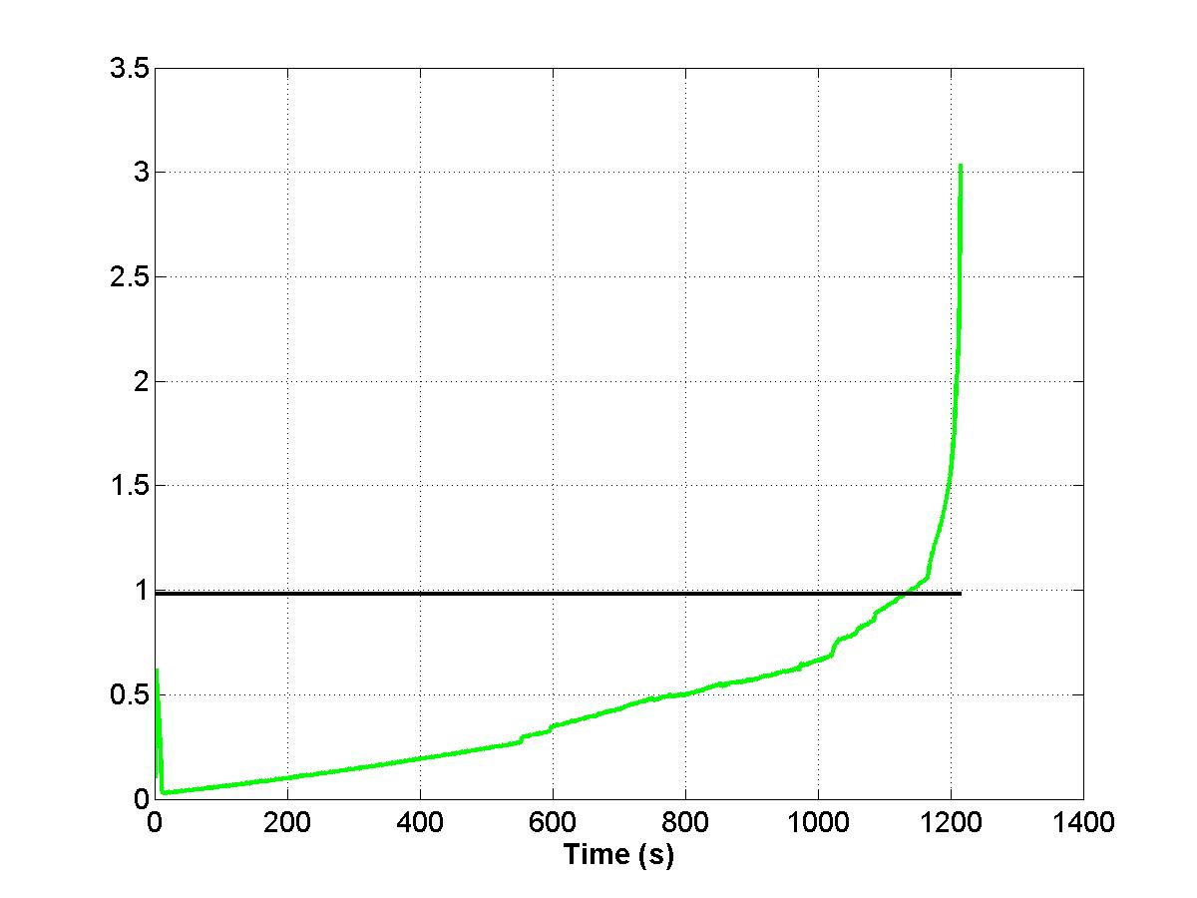 | 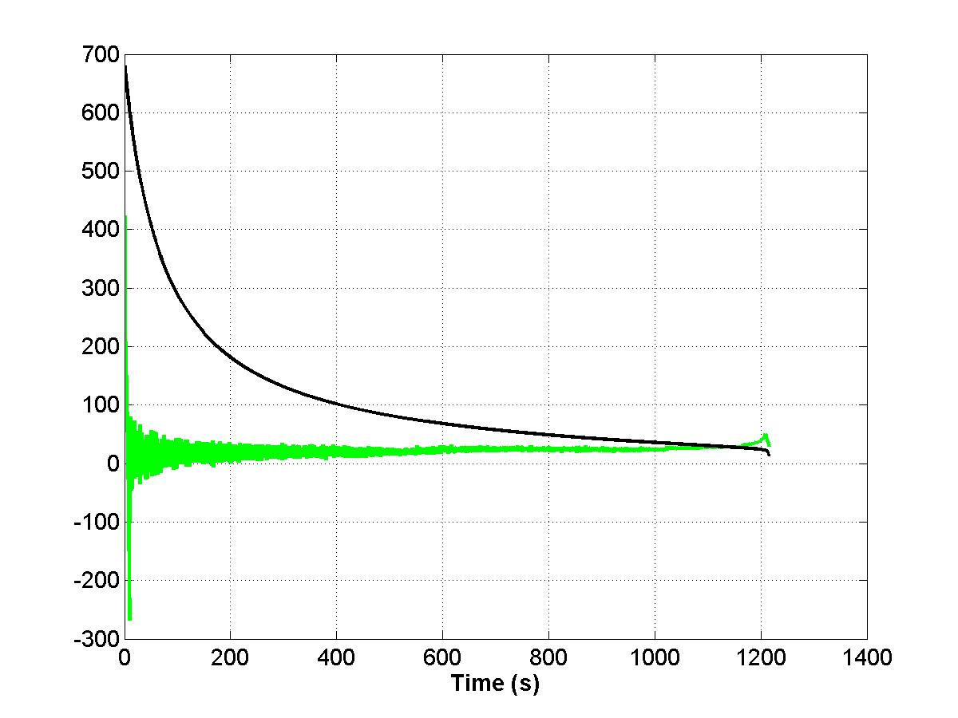
Fig. 9. Index I0 – Poggio | Fig. 10. Index I1 – Poggio | Fig. 11. Index I2 – Poggio

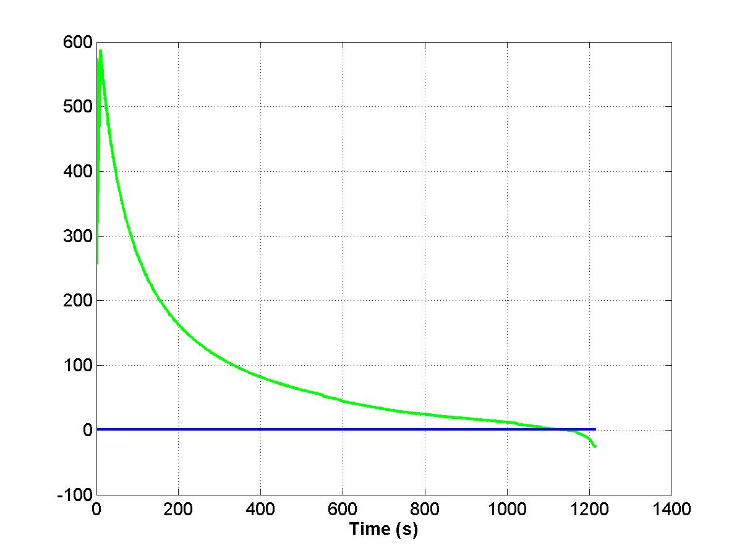 | 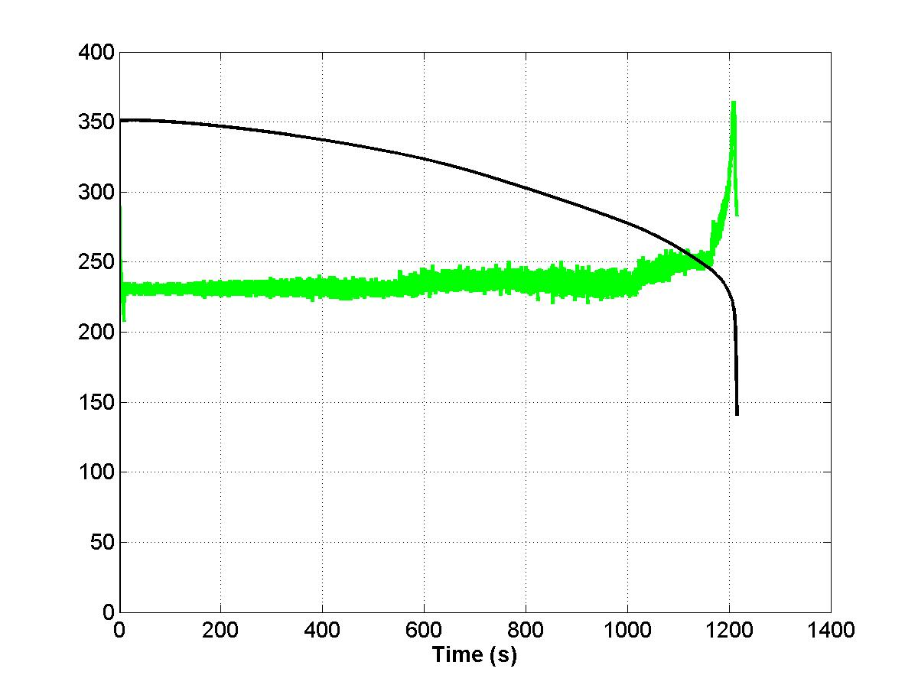 | 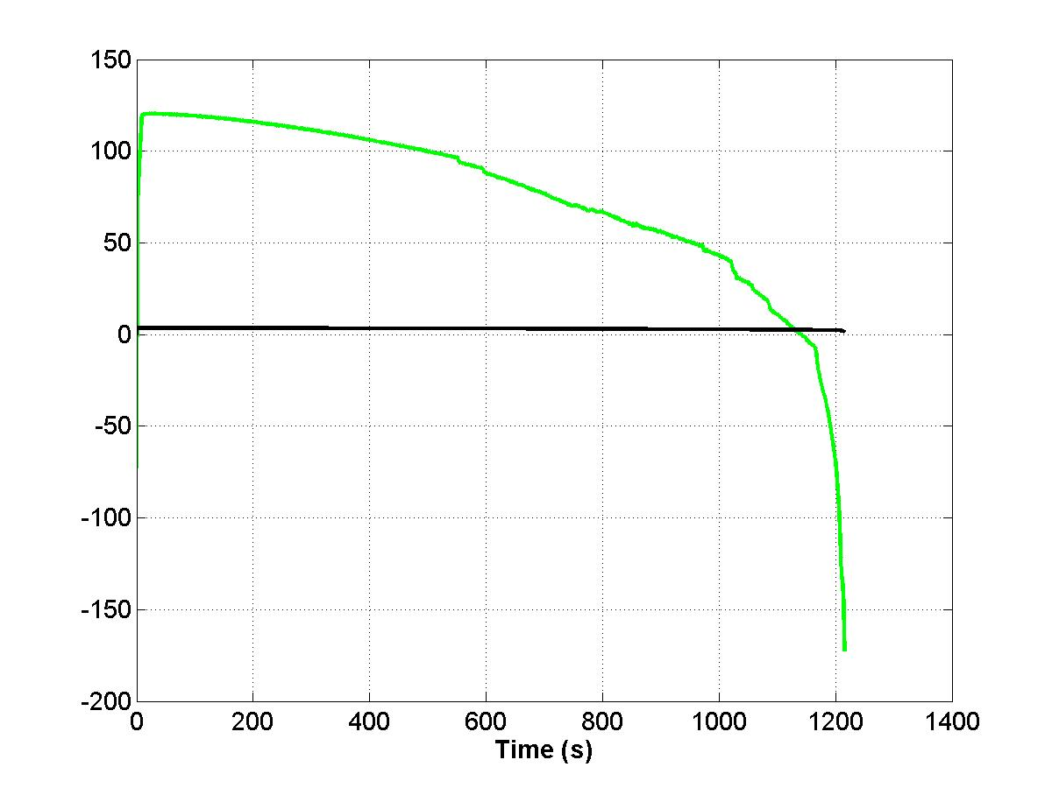
Fig. 12. Index I3 – Poggio | Fig. 13. Index I4 – Poggio | Fig. 14. Index I5 – Poggio

The results obtained for the Brugherio and P. a Caiano buses indicate similar performance in the indices derived from the identified Thevenin parameters, i.e., from I0 to I5. A different behavior is observed from index I6 that is based on the bus voltage magnitude.
Figs. 15 and 16 show the simulation of Index I6 for the Brugherio and P. a Caiano buses, respectively.
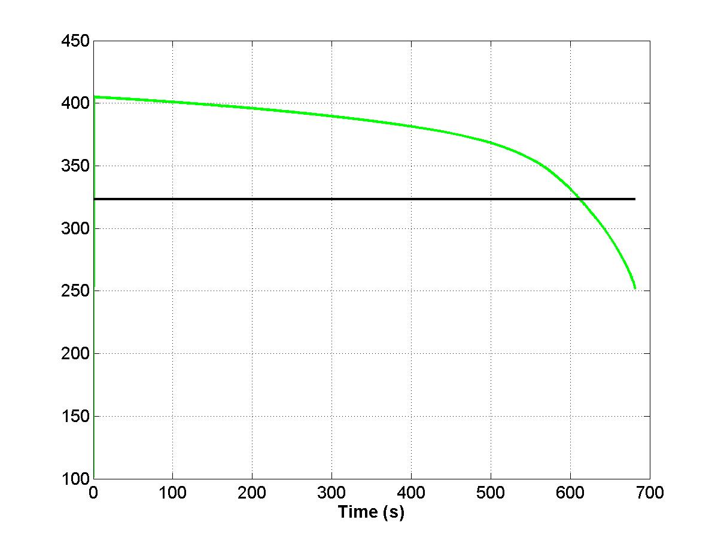 | 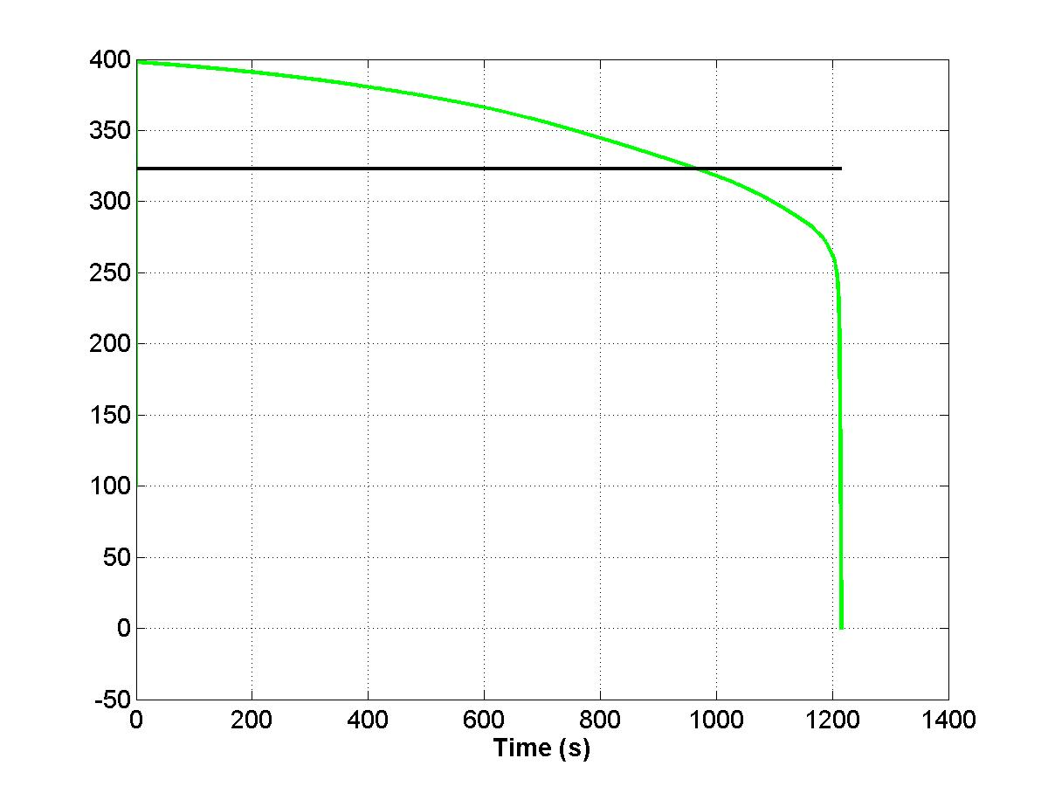
Fig.15 – Index I6 for the Brugherio Bus | Fig.16 – Index I6 for the P. a Caiano Bu

Looking at Figs 3-16 and Table I, one can note the anticipated time given by the indices that use derivative terms (grey columns in Table I). This puts an important role on the weight of the derivative term. As an example, Fig. 17 shows the influence of the derivative term $ρ_{X}$ in the index I2 for the Brugherio Bus. The plots are taken for values of $ρ_{X}$ = 1, 10 and 50. The larger $ρ_{X}$, the wider the curves. Fig. 18 is a zoomed view of Fig.17 near the crossing of the Thevenin and the load impedances. As expected, the anticipation effect due to the derivative term can be clearly noted. The time the impedances become equal is 485, 474 and 439 sec for $ρ_{X}$ = 1, 10 and 50, respectively.
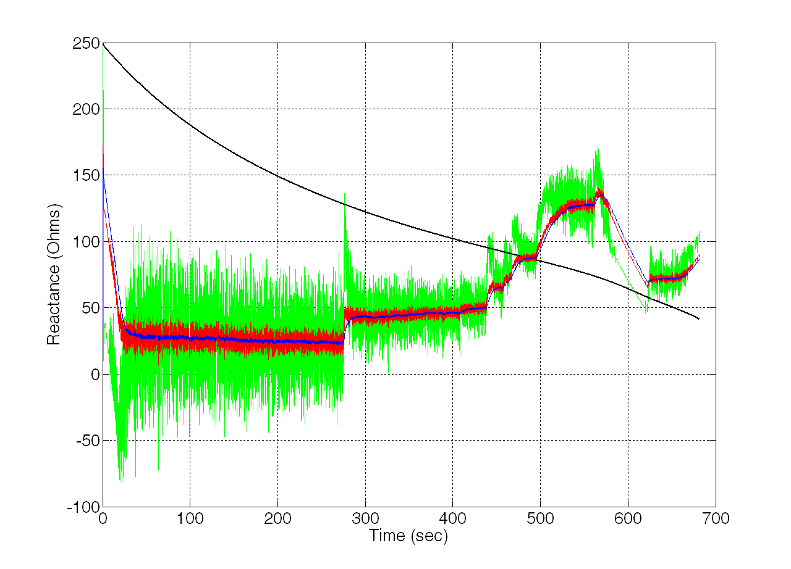 | 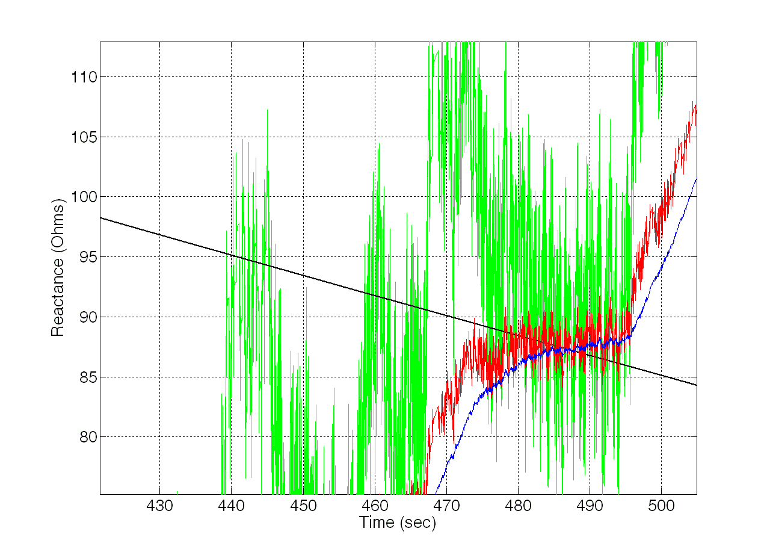 | 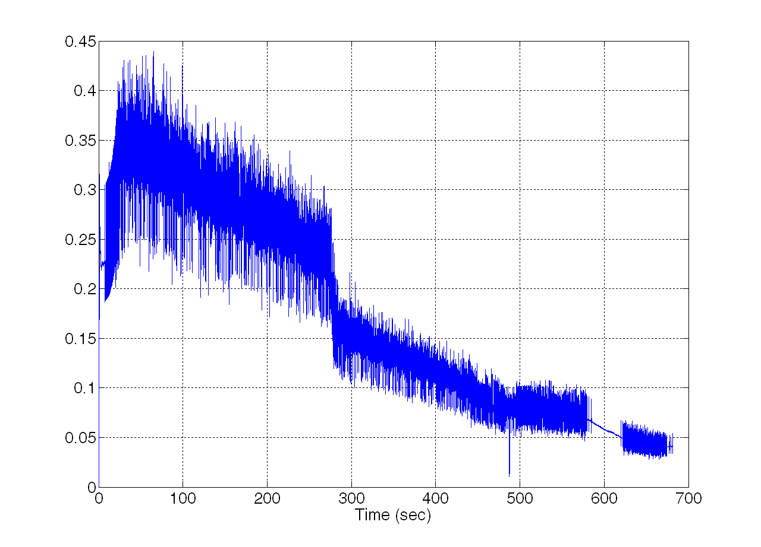
Fig.17 – Influence of the weight on the derivative term | Fig.18 – Zoomed view of Fig.15 | Fig.19 – Standard deviation for Index I3

An important term for index I3 is the standard deviation computed in a sliding window of the identified Thevenin reactance. Fig. 19 shows the standard deviation $σ_{X_{i}}$used in I3. From simulated plots like this it is possible to establish a priori the term $σ_{X\text{min}}$, also used in I3. It is worth noting the decrease in the standard deviation value as the system approaches instability.

V. Performance of the Indices in Front of Large Perturbations
In order to better assess the robustness of the proposed indices, we have done simulations in front of large perturbations. Another two sets of tests were performed – one considering a saw-teethed load variation and the other considering a step load variation. Tests were done for the P.Caiano bus only.
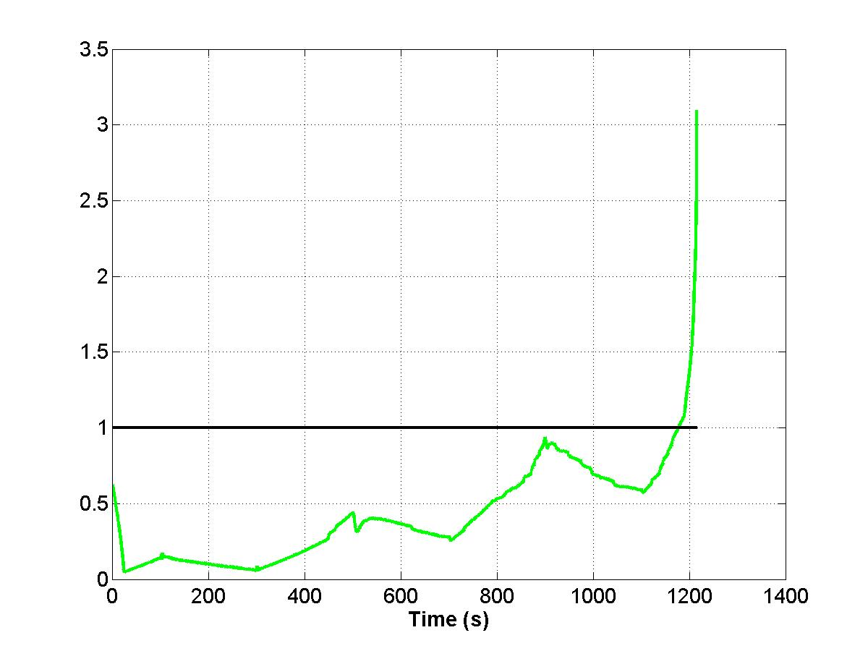 | 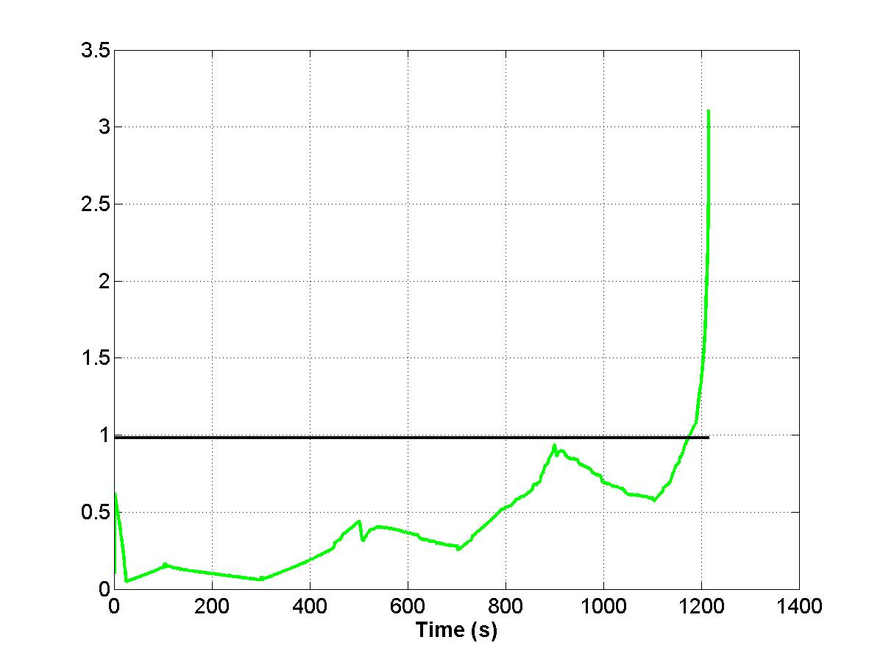 | 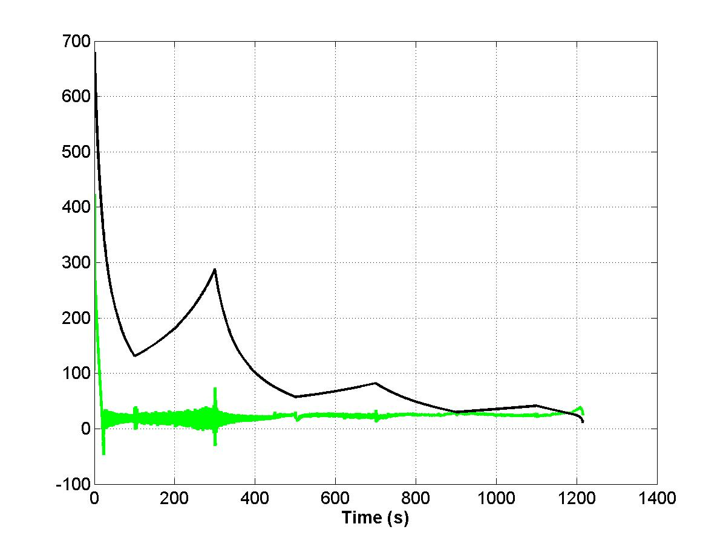
Fig. 20. Index I0 saw-teeth | Fig. 21. Index I1 saw-teeth | Fig. 22. Index I2 saw-teeth

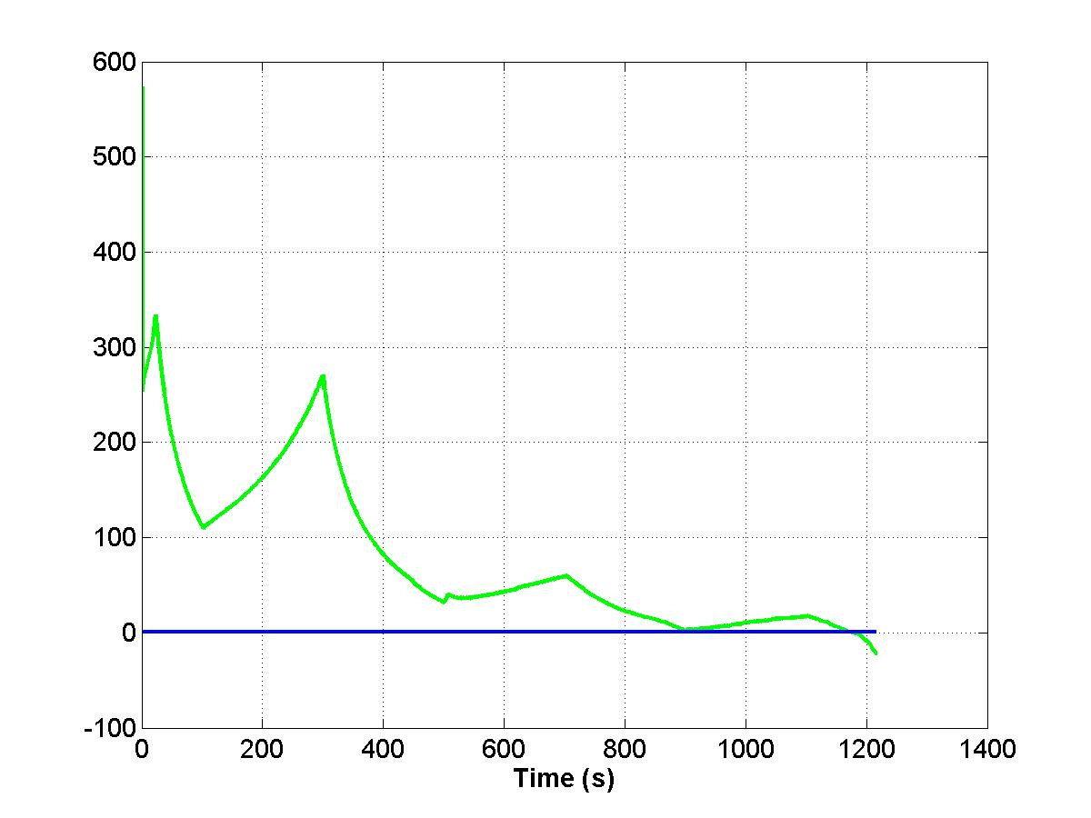 | 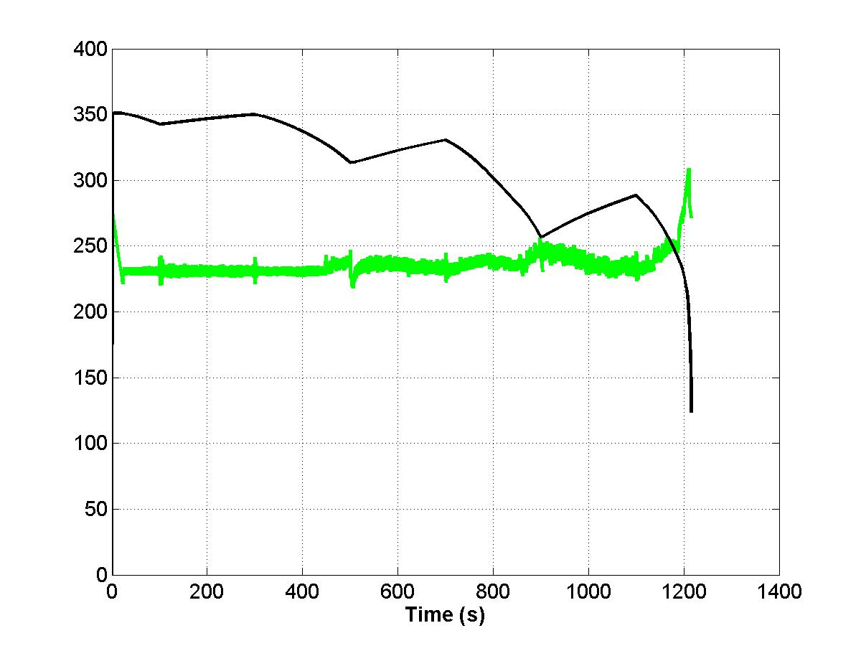 | 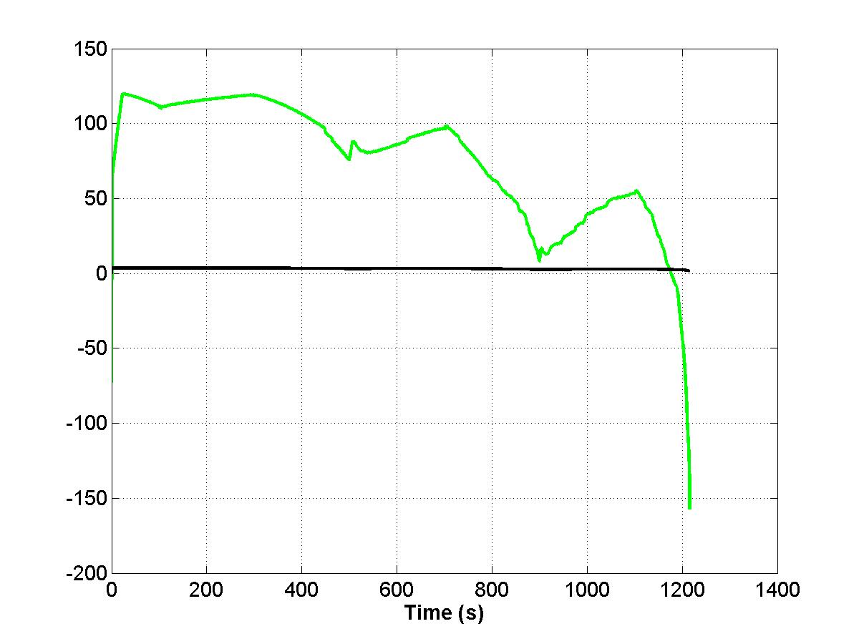
Fig. 23. Index I3 saw-teeth | Fig. 24. Index I4 saw-teeth | Fig. 25. Index I5 saw-teeth

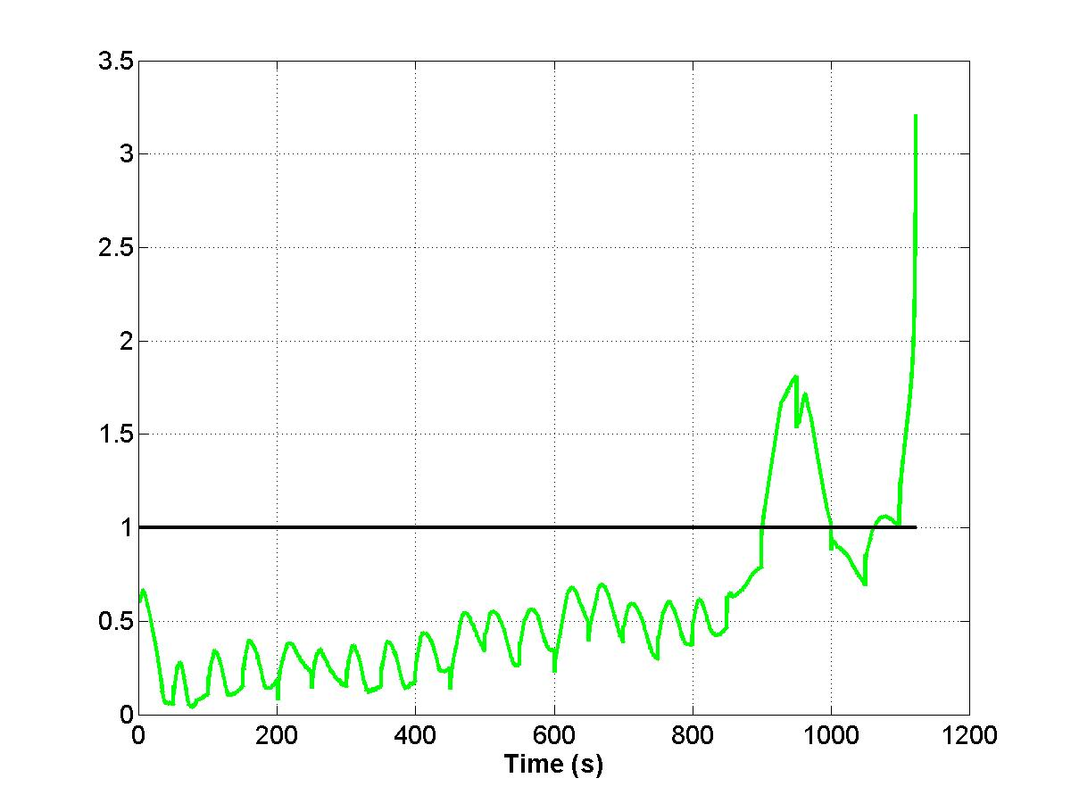 | 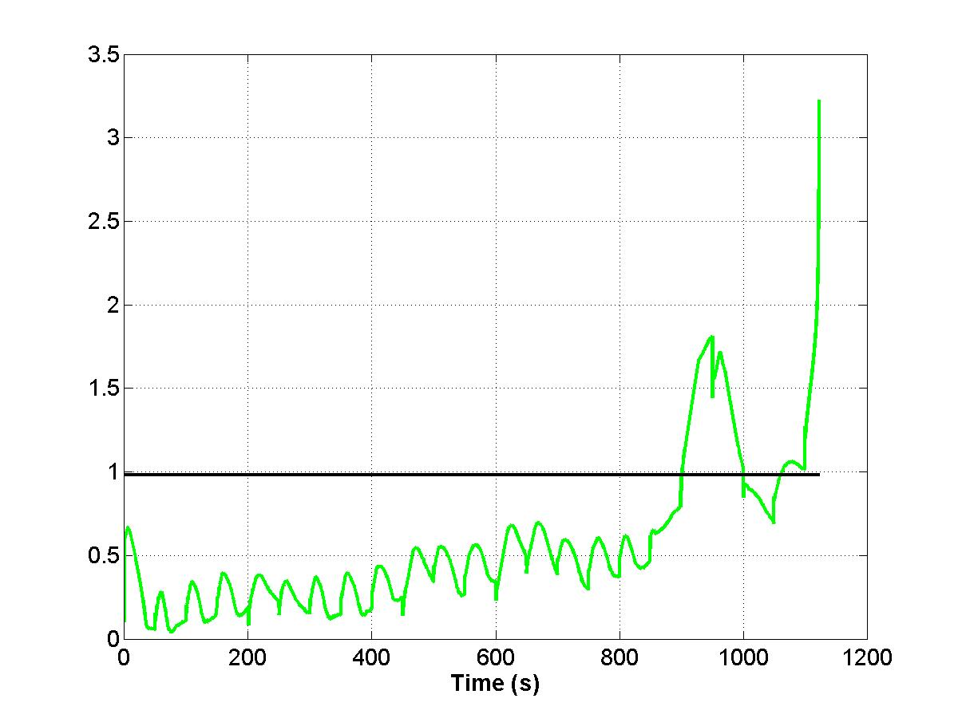 | 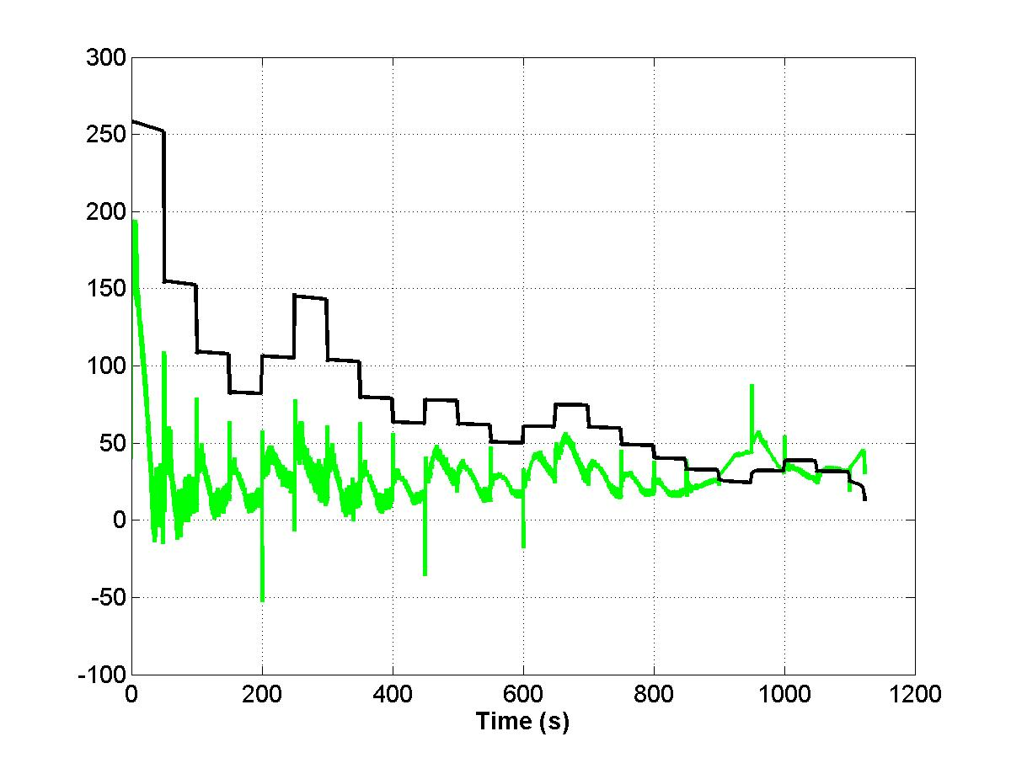
Fig. 26. Index I0 Step | Fig. 27. Index I1 Step | Fig. 28. Index I2 Step

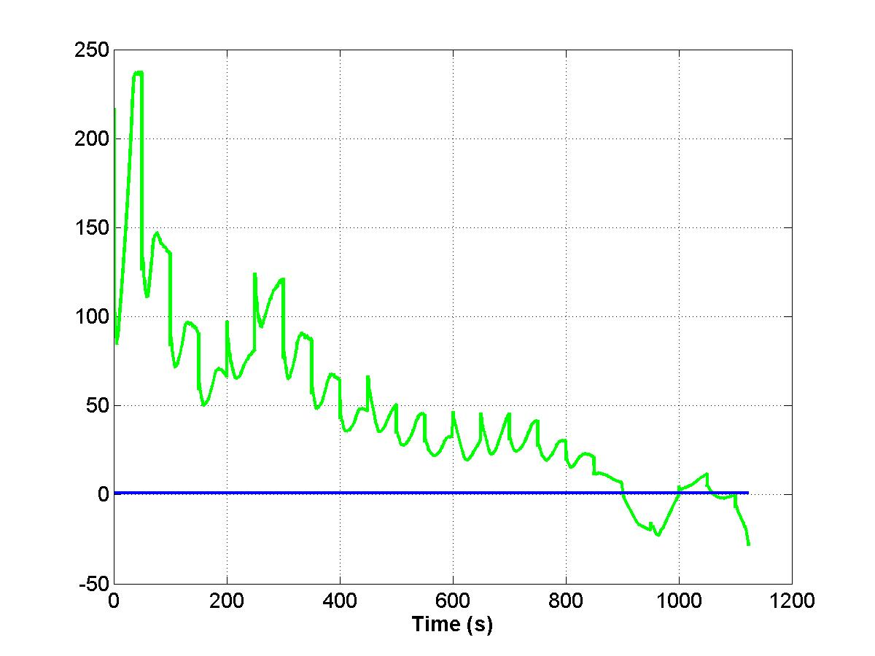 | 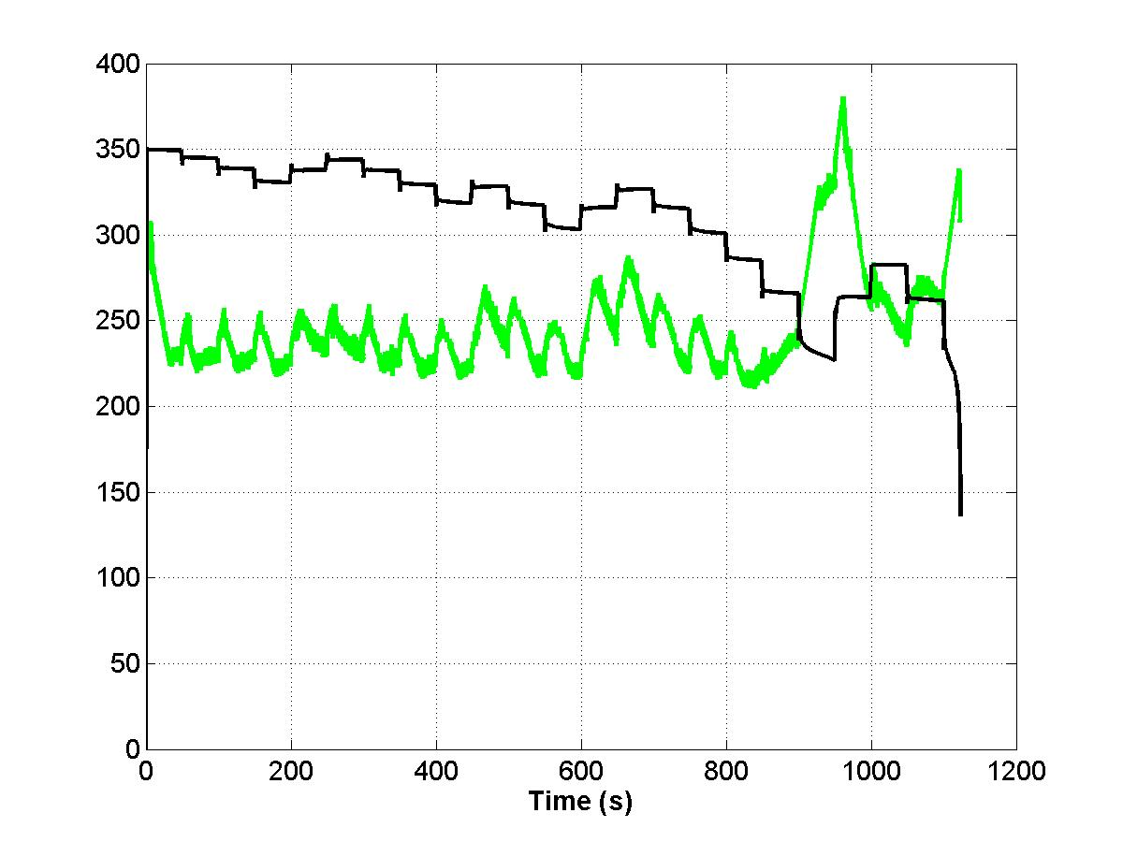 | 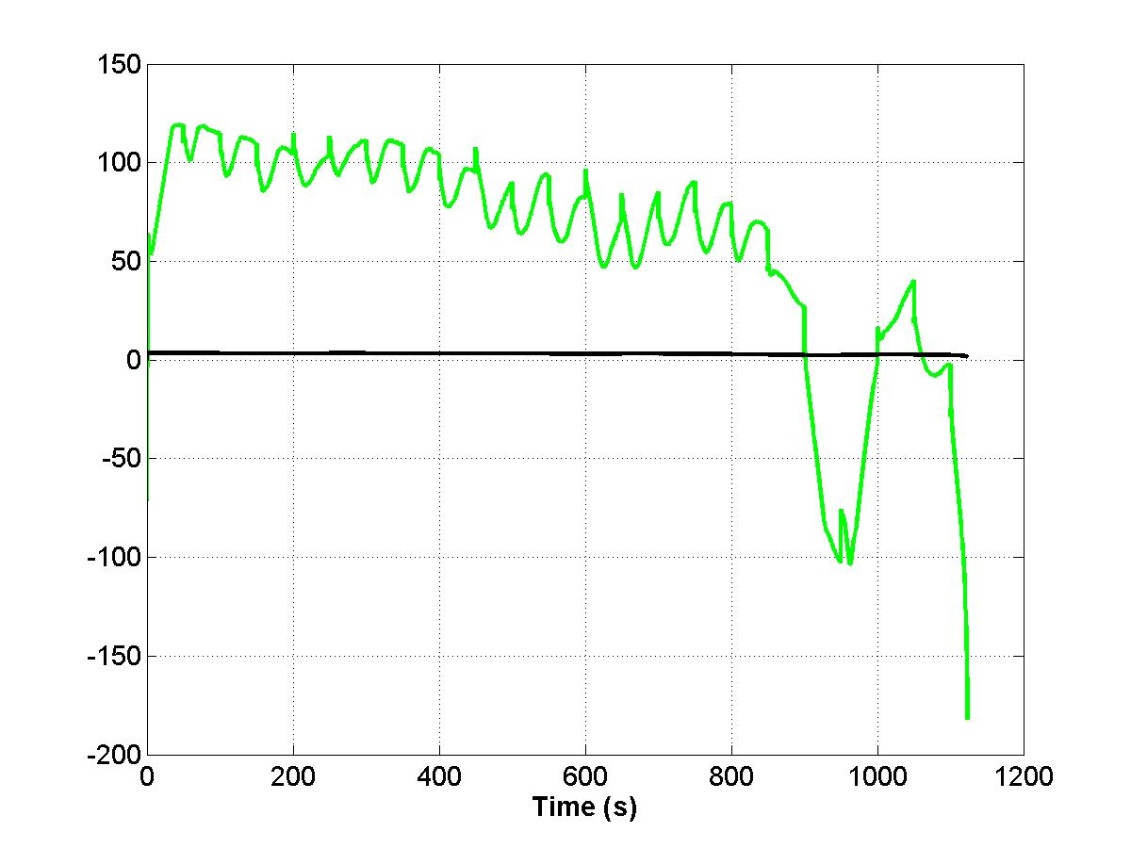
Fig. 29. Index I3 Step | Fig. 30. Index I4 Step | Fig. 31. Index I5 Step

Table II summarizes the performance of the proposed indices in terms of the time (in seconds) where a voltage instability alarm would trigger.
Table II – Time in seconds to voltage instability given by each index
Load variation | I0 | I1 | I2 | I3 | I4 | I5 | I6
Saw-teethed | 1176,3 | 1173,7 | 1172,4 | 1171,4 | 1172,8 | 1173,7 | 848,3
Large steps | 900,0 | 900,0 | 850,0 | 900,0 | 900,0 | 900,1 | *
*reaches the threshold since the first load step variation.

Once again the different behavior of I6 compared to the other indices can be noticed. Thus, we remark that relying only on bus voltage magnitude to anticipate voltage instability or collapse is not a very reliable strategy to be adopted.
VI. Conclusions
The paper proposes a real-time identification algorithm of voltage instability, able to recognize in a very fast and reliable way the raising of the voltage instability phenomenon seen by an EHV bus provided with PMU. The paper also proposes and compares some real-time voltage instability indicators proposed for practical applications and based on the above innovating identification procedure. The objective of these indicators is to correctly anticipate, when operating on line and in real time, the approaching, in a short while, of voltage instability. The achievement of this objective will surely allow relevant improvement in power system control and protection to increase system stability and security. The proposed identification algorithm and voltage instability indicators are deeply checked by dynamic tests performed on the Italian large power system through a detailed simulation model and data acquisition at the sampling rate of 20ms. The effectiveness of the identification algorithm was confirmed by the very satisfactory results of the proposed indicators with minimum differences each other in recognizing and indicating the risk of instability. The indicators including derivative terms can help in anticipating the incoming risk but the performed test in the presence of large perturbations showed the need to contain the gains of the derivative terms to avoid untimely-false alarms. The performed tests refer to heavy load increased according to a continuous ramp but also saw-teethed and step variations, therefore checking the robustness of the proposed indicators. The results are very clean and precise, notwithstanding the continuous changing of the real system data (50 Hz band) and the identification high speed (m=4 ⇔ 80ms) imposed. The described real-time reliable indicators can be effectively used in real transmission systems being very simple and at low computational cost.

BIBLIOGRAPHY

- S. Corsi and M. Pozzi, “A Real-Time EHV Bus-Bar Indicator of Local Voltage Instability”, IFAC Symposium on Power Plants and Power Systems Control, Calgary, Canada, June 2006.
- A. G. Phadke, “Synchronized Phasor Measurements in Power Systems”, IEEE Computer Applications in Power, Vol. 6, No. 2, pp. 10-15, April 1993.
- K. Vu, M. M. Begovic, D. Novosel and M. M. Saha, “Use of Local Measurements to Estimate Voltage-Stability Margin”, IEEE Transactions on Power Systems, Vol. 14, No. 3, pp. 1029-1035, August 1999.
- B. Milosevic and M. Begovic, “Voltage-Stability Protection and Control Using a Wide-Area Network of Phasor Measurements”, IEEE Transactions on Power Systems, Vol. 18, No. 1, pp. 121-127, February 2003.
- G. Verbic and F. Gubina, “A New Concept of Voltage-Collapse Protection Based on Local Phasors”, IEEE Transactions on Power Delivery, Vol. 19, No. 2, pp. 576-581, April 2004.
- I. Smon, G. Verbic and F. Gubina, “Local Voltage-Stability Index Using Tellegen’s Theorem”, IEEE Transactions on Power Systems, Vol. 21, No. 3, pp. 1267-1275, August 2006.
- IEEE/CIGRE Joint Task Force, “Definition and Classification of Power System Stability”, IEEE Transactions on Power Systems, Vol. 19, No. 3, pp. 1387-1401, August 2004.
- S. Corsi, “Wide-Area Voltage Regulation and Protection: when their coordination is simple”, Proceedings of the IEEE St. Petersburg PowerTech, Russia, 2005.
- S. Corsi and G. N. Taranto, “Voltage Instability – the Different Shapes of the “Nose”, Bulk Power Systems Dynamics and Control VII, IREP Conference, Charleston, SC, USA, Augst 2007.
- S. Corsi and G. N. Taranto, “A Real-Time Voltage Instability Risk Indicator Based on Local Phasor Measurements,” submitted to the IEEE Transactions on Power Systems.

